IDFB Life Cycle Assessment Talking Points for Members

Background
- Life Cycle Assessments (LCA) provides an accurate picture of the true environmental trade-offs in product selection. By analyzing the impacts throughout a product life cycle you will gain a comprehensive view of the product and processes, an understanding of where improvements can be made and validity in your sustainability measures. It is your first step in the sustainability journey.
- The Life Cycle Assessment was conducted by Long Trail Sustainability (LTS), an independent third-party specializing in product-based environmental analysis reports.
- The LCA conforms to ISO 14040 and 14044 guidelines
  - Full comparative LCA panel of 3 reviewers
  - Provides reassurance to the commissioner that the study was done correctly and presents quality information
  - Provides reassurance to readers that the results presented are backed up by science
  - Provides solid substantiation against claims of false advertising or “greenwashing”
  - Reviewers do not endorse product, just state whether the study followed the guidelines
Process
- Factory reported Life Cycle Inventory (LCI) data of Down Fill Material includes: Pre washing, Sorting, Washing, Drying, Dedusting and Mixing
- Down System boundaries: Raising of the ducks/geese and processing of the down including energy, water and detergent
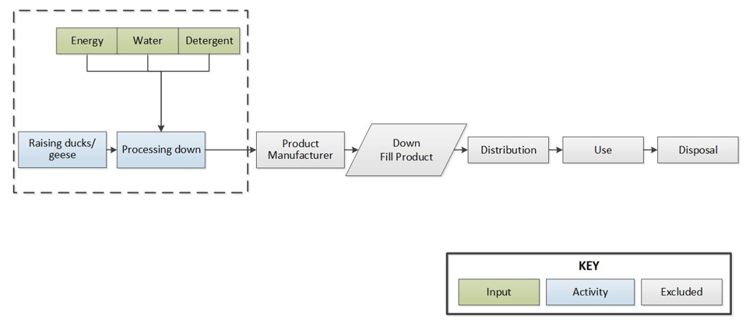
- Factory reported LCI data of Polyester Fill Material includes: PET material (from ecoinvent), Electricity and steam for spinning process sourced from literature van der Velden (2014) and with a Lifetime of 2 years (therefore 3 replacements are needed over 5 years, the functional unit duration)
  - This is tested in sensitivity analyses and does not change the conclusions.
- Polyester System boundaries: Processing the polyester including PET, heat and electricity
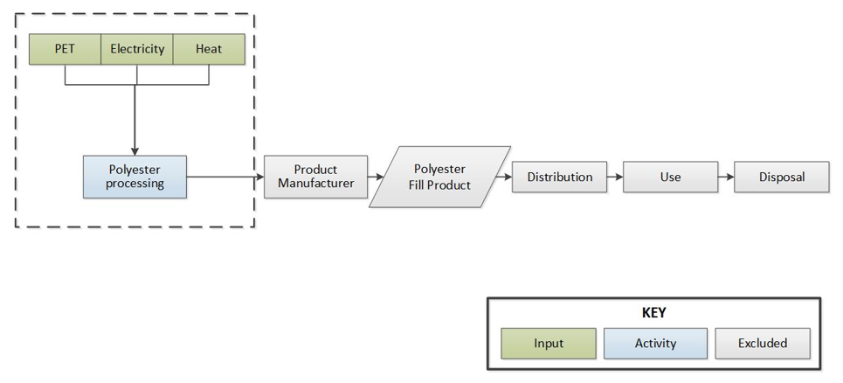
- Primary data from the report comes from 8 manufacturers for 2017 annual production data
- Secondary data (Used literature, DATASMART 1 and ecoinvent 3.4 2) was collected for LCI data for raw materials, manufacturing, energy production and Transport
Areas Assessed for Environmental Impact
- Human Health: Disability Adjusted Life Years (DALY)
  - Includes human health impacts from Climate Change, Human Toxicity, Photochemical Oxidant Formation, Particulate Matter Formation, Ionizing Radiation, and Ozone Depletion
- Ecosystems: Species * yr
  - Includes ecosystem impacts from Climate Change, Terrestrial Acidification, Freshwater Eutrophication, Ecotoxicity, Agricultural Land Occupation, Urban Land Occupation and Natural Land Transformation
- Resources: $/kg
  - Includes resource impacts from Fossil Depletion and Metal Depletion
- Cumulative Energy Demand: MJ
  - Includes nonrenewable and renewable energy sources
- Climate Change: kg CO2 eq.
  - Combines the effect of the periods of time that the various greenhouse gases remain in the atmosphere and their relative effectiveness in absorbing outgoing infrared radiation
Results
- Compared to the polyester fill material, the down fill material has 85% 94% fewer environmental impacts in all impact categories.
- In terms of climate change impacts, polyester has 18 times more impacts than down fill material.
- Even on a per ton basis (not taking into account performance or duration), down has lower impacts than polyester fill material in all categories.
- The majority of the cradle to gate impacts of the down fill material come from energy use and Raising ducks/geese

